

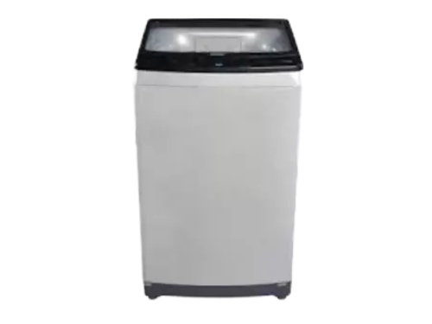

# Haier HWM 85 826 Automatic Washing

• SKU#:23994

• Item Condition: New

• Stock Info: Available

• Warranty: 1 Year Warranty/li>

• Machine 12Kg